It’s great to be able to get back on court and play badminton again but we all need to follow a few guidelines to maintain our safety

BEFORE attending LDBC
You will be required to complete a COVID questionnaire prior to attending
(this will be sent to everyone via email)
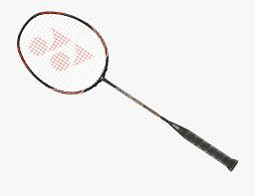
You must use your own racket and only bring necessary belongings with you into the hall. There will be no equipment available to loan, apart from shuttles
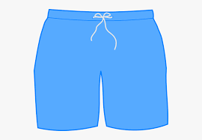
You will need to arrive dressed ready to play as no changing facilities will be open
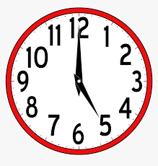
You must arrive EXACTLY on time as there will be NO waiting area
Please maintain social distancing when arriving
ARRIVAL at LDBC
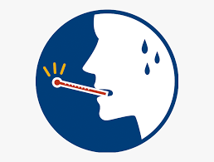
If you, or any member of your household are showing symptoms of COVID-19, please DO NOT attend the club - if you attempt to, you will be refused entry

Face coverings must be worn at all times within the building and
when not playing on court, including the toilets
You will find a desk before entry to the hall where you will register, pay (exact money only please) and have your temperature taken. You will also be asked a series of health questions
All carers/parents will be asked to remain on the viewing balcony
(unless there are exceptional circumstances)
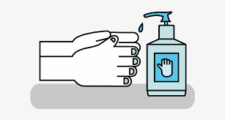
Please sanitise your hands every time you enter or leave the sports hall
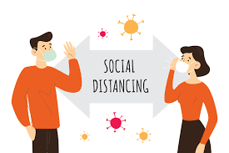
Everyone must observe social distancing at all times,
in all areas of the sports hall and centre.
Please stay 2 metres away from all players and coaches (including your friends)
Please follow the arrows upon entry to the hall to your assigned court
and sitting area - you must NOT enter any other court space.

DURING LDBC playing time
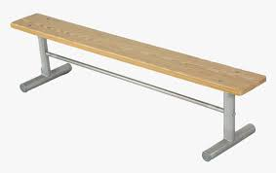
When not playing please sit on the bench at your designated spot beside your belongings and at least 2 metres away from anyone else

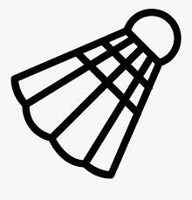
You can share shuttles but only between the people who are on your court
But try to avoid touching your face

You must sanitise your hands before and after each game
If you feel unwell at any time, please notify a coach
or the COVID officer immediately
LEAVING after the session
Please sanitise yours hands when you leave the sports hall
and maintain social distancing at all times
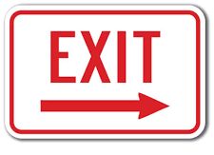
You must leave the hall promptly to avoid any crossover between playing groups

